BOOP lab manual Name : Veer R Patel enrollement no. :10

Q.2 ) Develop minimum 5 program using cin and cout.

Program1

🡪Addition of two number

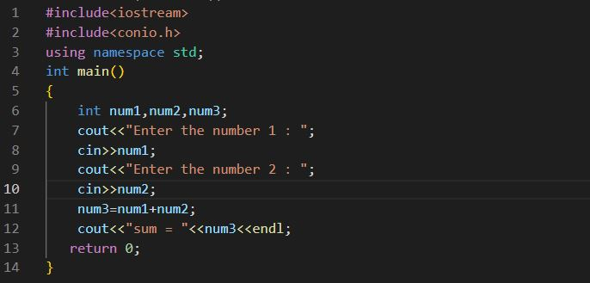

Output

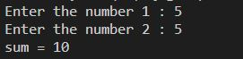

Program2

🡪Subtraction of two number

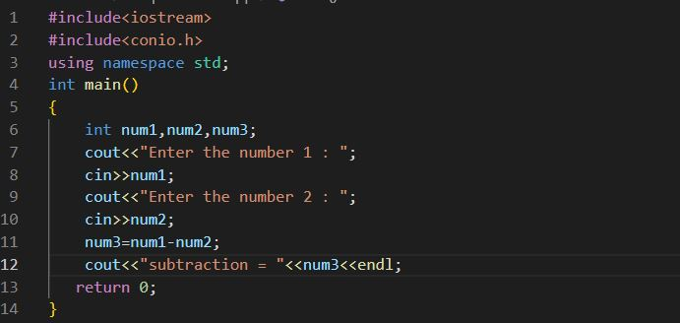

Output

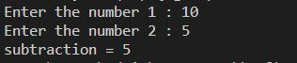

Program 3

🡪Multiplication of two number

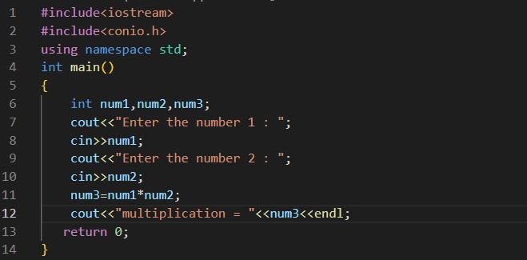

Output



Program 4

🡪Division of two number

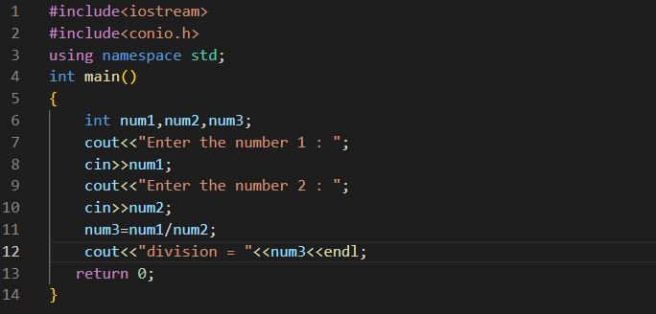

Output



Program 5

🡪Program to print the number

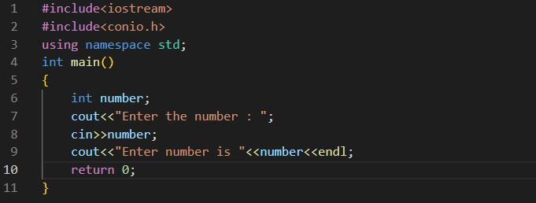

Output

